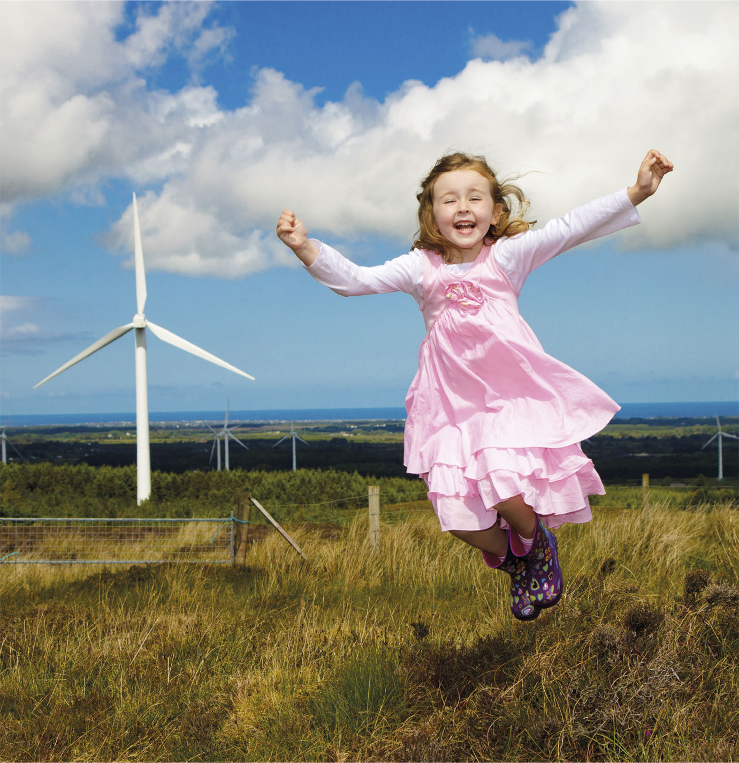
SSE Airtricity Community Fund
Application Form

1 April 2020 – 31 March 2021

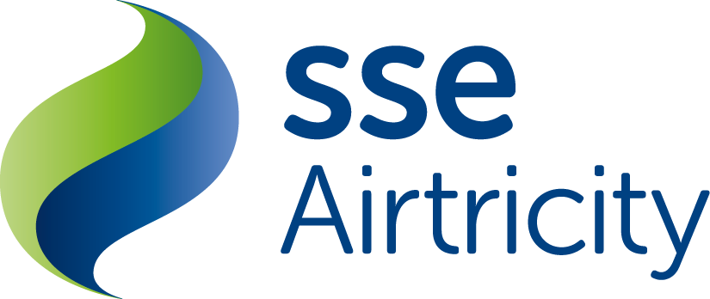

What is a Community Fund?
“At SSE Airtricity we believe in making energy better. That’s why as well as promoting green energy generation we believe the communities in which we locate our wind farms should be able to see and experience the benefit of that wind farm in their locality.”

SSE Airtricity Community Fund 2019 / 2020 – Application Form

The SSE Airtricity Community Fund aims to support energy efficiency and sustainability projects in the locality of our wind farms. The fund is paid out annually; starting one year after the wind farm starts producing electricity and operates for the lifetime of each site.
The SSE Airtricity Community Fund is only paid out in respect of wind farms wholly owned by SSE Airtricity.

Who can apply?
All communities within a 20km radius of any of our wind farms across the island may apply. However, we place
a particular emphasis on prioritising those community groups located within a 5km vicinity of each wind farm. This application process is open to Not-For-Profit organisations only. This fund is not open to applications that support individuals however individuals may apply for funding to support a community initiative.

What kind of projects do you fund?
Our funds support a variety of projects under the criteria below. We prioritise energy efficiency projects currently.

Application Criteria
1 | Energy Efficiency  Your project delivers reduced energy consumption through energy efficiency.
2 | Sustainability  Your project drives community centred environmental and / or social sustainability interest.
3 | Safety  Your project will enhance the safety for members of the community
4 | COVID-19 Response  Applications for projects requiring support due to Covid-19

How much does each fund pay?
The size of each Community Fund is different as it is calculated on the total amount of electricity produced at the wind farm each year. So, during particularly windy years, a wind farms Community Fund will be bigger.

How the Community Fund works.
1 | Tell Us About Your Project  SSE Airtricity will advertise the fund in the local press.  Fill out this application form, telling us about your community group and your project. Remember to attach contractor quotes for the measure you are applying for.
2 | Send Us Your Project Details  Submit your completed application form to our Community Development Officer, Anne Reynolds. This can be done via post or email to communityfundireland@sse.com.
3 | SSE Airtricity Reviews all Projects  All Community Fund applications are evaluated on a competitive basis – remember energy efficiency projects will be prioritised. The scoring panel will also consider proximity to the wind farm and the number of beneficiaries.
4 | Funding Awards  SSE Airtricity Community Development Officer, Anne Reynolds, will contact all applicants, letting them know if they were successful or unsuccessful this year and how much funding their respective projects are to be awarded.
5 | Community Photo  If your application is successful, Anne Reynolds will organise a visit to your community and present successful groups with their Community Funding award.

For more information
You can find out more about the SSE Airtricity Community Fund by contacting Anne at:

Anne Reynolds, Community Development Officer,
SSE Airtricity, Red Oak South, South County Business Park, Leopardstown, Dublin 18, Ireland.
Email: anne.reynolds@sse.com
Tel: +353 1 655 6556
Fax: +353 1 655 6444
www.sseairtricity.com
www.Ireland.sse.com

For project ideas please contact Anne for suggestions.
SSE Airtricity Community Fund 2019/2020 – Application Form

Applicant Details
Name of Organisation/Group (Please provide name that will appear on cheque should your application be successful): |  |  | Address:
Main contact for the Organisation/Group:
Name: |  | Tel: |  | E-mail:
How many people are involved in your Organisation/Group?
Full-time Staff: | Part-time Staff: |  | Volunteers: |  | Members:
Is the Organisation a Registered Charity? Yes / No |  |  | Please Quote Registration Number:
What does your Organisation/Group do for the local community?

Project Details
Project Title: |  |  | Location:
Please tell us the three key objectives of your project.
1.

2.

3.

Please give a brief description of your proposed project explaining the project background. (no more than 200 words)

What is the overall cost of the project?
Please select your project type:
New build | Extension to existing building |  |  | Retrofit of existing building
Does your project align with one or more of the following criteria?
Encourage involvement within your local community? |  |  |  |  | Yes / No (delete as appropriate)
Provide a benefit to members of your local community? |  |  |  |  | Yes / No (delete as appropriate)
Help deliver reduced energy consumption through energy efficiency? |  |  |  |  | Yes / No (delete as appropriate)
Help to drive environmental sustainability within your local community? |  |  |  |  | Yes / No (delete as appropriate)
Contribute to the long-term social sustainability of your local community? |  |  |  |  | Yes / No (delete as appropriate)
Improve safety for the community? |  |  |  |  | Yes / No (delete as appropriate)
What energy efficiency / sustainability / safety or covid-19 response aspect of the project will the SSE Airtricity contribution support?
*Please attach one relevant contractor quote(s).
What is the cost of this element of the project? €
Amount of assistance sought from the Community Fund? €
How much funding have you raised already for the project? €
What is the approximate number of beneficiaries?
When do you expect the project to start? |  | When do you expect to finish the project?
Please give details of previous Community Fund applications made in the last 3 years
Year/s: |  | Project/s:
Outcome/s:

Property Information (Please complete as appropriate if you are applying for an energy efficiency project)
What is the main function of your property? | What year was the building constructed?
What is your existing heating fuel?  (Oil, Gas, Electricity, LPG) | Does this Heating Fuel also heat your hot water?  Yes / No (delete as appropriate)
What is your current annual heating cost? € | What size is your Hot Water Cylinder? m³
MPRN (available on your electricity bill): | What is your current annual electricity cost? €
What is the current building usage profile (how many days per week and for how many hours is the building typically being used?)

Checklist
- Have you filled out every section of the application form to the best of your knowledge?
- Have you attached completed contractor quote form for the relevant element of your project?
- Have you provided authorisation to SSE Airtricity to access your energy bills?
- Have you submitted a signed declaration form?
Once submitted you will receive confirmation of receipt by email or phone. If you do not hear from us please ring Anne on 01 6556556.

Interested in doing energy efficiency improvements to your own home?
To find out more please visit our Home Energy Services business at www.sseairtricity.com or call 1850 818170 to understand how SSE Airtricity can help you to improve the energy efficiency of your home or homes within your community. Working with SEAI we will process your grant applications for you and complete the work needed for your particular home.

Data protection
We will use the information you give us to help assess your application and administer any funding we award you. We may also use it to analyse our fund-making and for our own research. We may give copies of this information to individuals and organisations we consult when assessing applications, when monitoring funds and evaluating our programmes. We will hold the information you provide on this form for the life of the wind farm if you are successful in receiving an award, otherwise we will hold the information you provide for a period no longer than three years if the application is unsuccessful. This information will be used for monitoring purposes, such as reporting and to identify repeat applicants.

